Switching & Routing Wireless Essentials (CCNA 2) Home Project

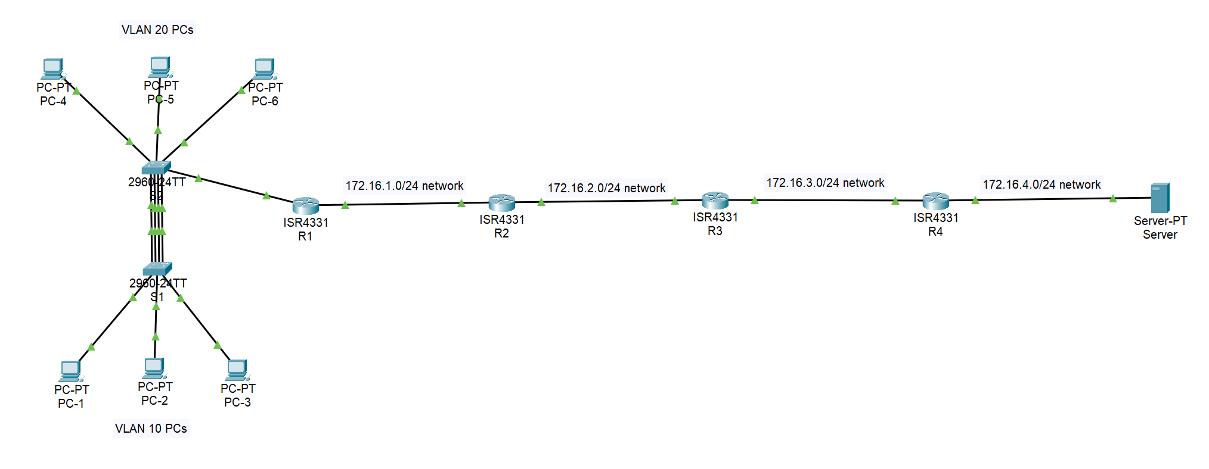

Addressing Table

| **Device** | **Interface** | **IP Address/Prefix/Link Local Address** | **Subnet Mask** | **Default Gateway** |
| --- | --- | --- | --- | --- |
| R1 | G0/0/0.10 | 192.168.1.1  172.16.4.9 helper  2001:DB8:ABCD:10::1/64  FE80::1 | 255.255.255.192 | *N/A* |
| *R1* | G0/0/0.20 | 192.168.1.65  172.16.4.9 helper  2001:DB8:ABCD:20::1/64  FE80::1 | 255.255.255.224 | N/A |
| *R1* | G0/0/0.30 | 192.168.1.97  2001:DB8:ABCD:30::1/64  FE80::1 | 255.255.255.240 | *N/A* |
| R1 | G0/0/1 | 172.16.1.1  2001:DB8:ABCD:1::1/64  FE80::1 | 255.255.255.0 | N/A |
| R2 | G0/0/0 | 172.16.1.2  2001:DB8:ABCD:1::2/64  FE80::1 | 255.255.255.0 | N/A |
| *R2* | G0/0/1 | 172.16.2.1  2001:DB8:ABCD:2::1/64  FE80::1 | 255.255.255.0 | *N/A* |
| R3 | G0/0/0 | 172.16.2.2  2001:DB8:ABCD:2::2/64  FE80::1 | 255.255.255.0 |  |
| R3 | G0/0/1 | 172.16.3.1  2001:DB8:ABCD:3::1/64  FE80::1 | 255.255.255.0 |  |
| R4 | G0/0/0 | 172.16.3.2  2001:DB8:ABCD:3::2/64  FE80::1 | 255.255.255.0 |  |
| R4 | G0/0/1 | 172.16.4.1  2001:DB8:ABCD:4::1/64  FE80::1 | 255.255.255.0 |  |
| S1 | VLAN 30 SVI | 192.168.1.98 | 255.255.255.240 | 192.168.1.97 |
| S2 | VLAN 30 SVI | 192.168.1.99 | 255.255.255.240 | 192.168.1.97 |
| PC-1 | NIC | DHCP  2001:DB8:ABCD:10::2/64  FE80::2 | DHCP | FE80::1 |
| PC-2 | NIC | DHCP  2001:DB8:ABCD:10::3/64  FE80::3 | DHCP | FE80::1 |
| PC-3 | NIC | DHCP  2001:DB8:ABCD:10::4/64  FE80::4 | DHCP | FE80::1 |
| PC-4 | NIC | DHCP  2001:DB8:ABCD:20::2/64  FE80::5 | DHCP | FE80::1 |
| PC-5 | NIC | DHCP  2001:DB8:ABCD:20::3/64  FE80::6 | DHCP | FE80::1 |
| PC-6 | NIC | DHCP  2001:DB8:ABCD:20::4/64  FE80::7 | DHCP | FE80::1 |
| Server | NIC | 172.16.4.9  2001:DB8:ABCD:4::9/64  FE80::8 | 255.255.255.0 | 172.16.4.1  FE80::1 |

This is a project in Cisco Packet Tracer I put together from the skills I learned in the CCNA 2 class I took in the Spring of 2024. It consists of subnetting, inter-vlan routing, VLAN creation, network infrastructure (trunking with VLANs, configuring etherchannel, configuring access ports, and assigning port security on access ports), and host support (IP routing and DHCP setup).

The image I have on the first page shows my topology. I have 6 PCs, 3 assigned to a single VLAN, 2 switches, 4 routers, and a server.

The first task I did was take the IP address of 192.168.1.0/24 and subnet it into 4 networks.

I need 2 bits to create 4 networks. 2 bits means a /26 subnet mask for the networks. The new subnetted networks are:

**192.168.1.0/26**

**192.168.1.64/26**

**192.168.1.128/26**

**192.168.1.192/26**

Each last octet was added by 64, 64 coming from the binary chart.

From the addressing table, I assigned the subnetted networks to the subinterfaces on R1.

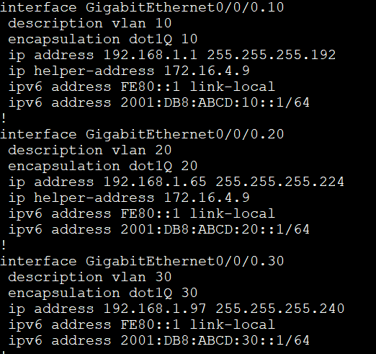

The show run configuration of the R1 subinterfaces.

As my topology shows, I have different networks between each router. They consist of 172.16.1.0/24, 172.16.2.0/24, 172.16.3.0/24, and 172.16.4.0/24. These are necessary for my IP routing and for the routers to communicate with every device in the network.

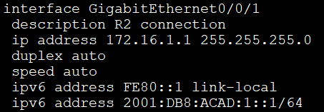

Interface G0/0/1 on R1 is connected to R2. This is its configuration.

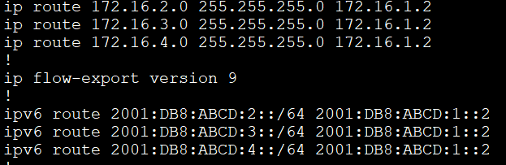

These are the IP routes on R1. It needs to know about the 172.16.2.0, 3.0, and 4.0 network. With these routes configured, R1 can communicate with every interface of each router.

The next hop address, 172.16.1.2 for IPv4, and 2001:DB8:ABCD:1::2 for IPv6, doesn’t change.

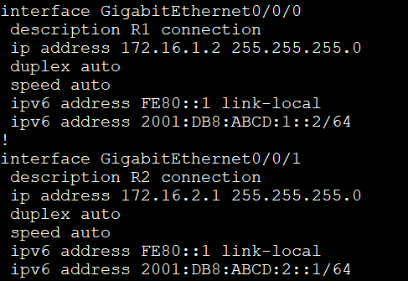

These are the interface configurations on R2.

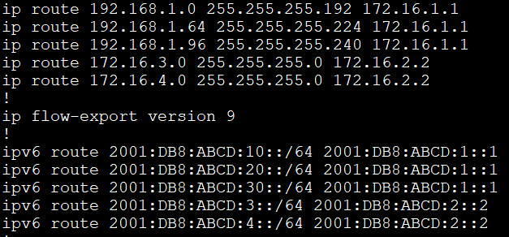

These are R2’s IP routes. R2 needs to know about the VLAN networks on R1, and the networks between R3 and R4, and between R4 and the server.

The next hop address for IPv4 and IPv6 doesn’t change when R2 needs to know about the VLAN networks. It changes when it needs to know about the networks between R3 and R4, and between R4 and the server.

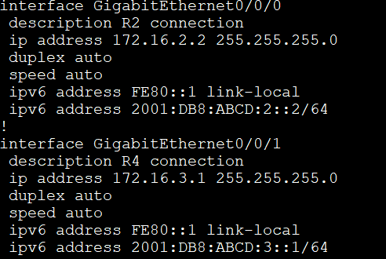

These are the interface configurations on R3.

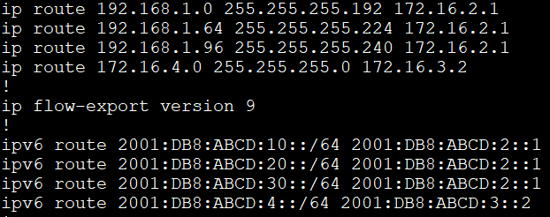

These are the IP routes on R3. R3 needs to know about the VLAN networks on R1, and the network between R4 and the server.

The next hop address doesn’t change when R3 needs to know about the VLAN networks. It changes when it needs to know about the network between R4 and the server.

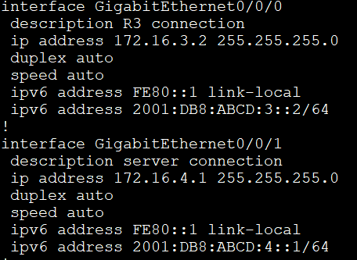

These are the interface configurations on R4.

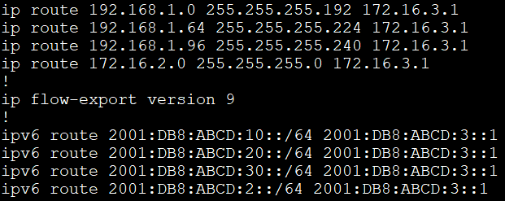

These are the IP routes on R4. R4 needs to know about the VLAN networks on R1, and the network between R2 and R3.

The next hop address doesn’t change when R4 needs to about the VLAN networks. It changes when it needs to know about the network between R2 and R3.

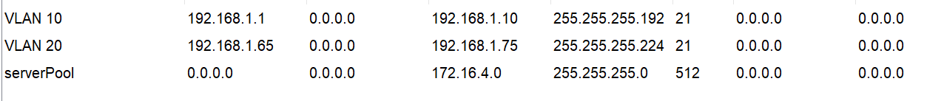

This shows the DHCP setup on the server. For each VLAN, I excluded the first 10 addresses in each subnet.

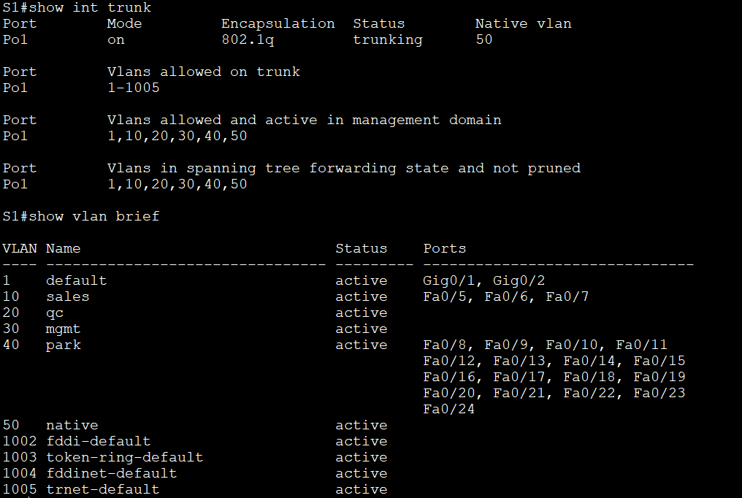

On S1, when I typed in **show int trunk,** it displayed the trunk configuration, with VLAN 50 as the native VLAN. Interfaces f0/1-4 on this switch are configured as trunks and all VLANs are allowed to cross.

**show vlan brief** shows the VLANs I created on this switch, and the ports I assigned to them. VLAN 10 has ports f0/5-7 and are access ports. VLAN 40 has the unused/shutdown interfaces assigned to it and are also access ports.

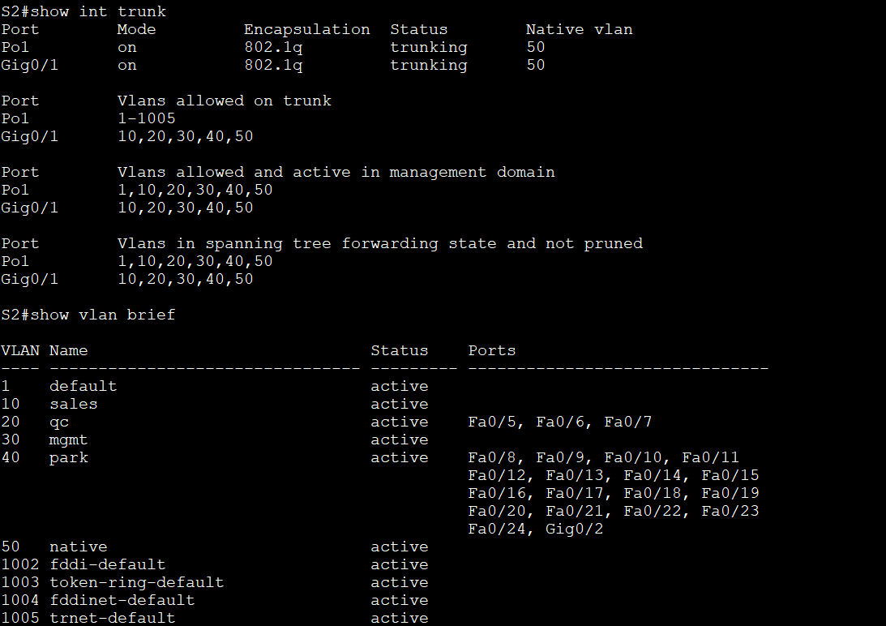

S2’s trunk configuration and VLAN brief. On this switch, because int g0/1 is connected to R1, it also is configured as a trunk, along with int f0/1-4. VLAN 50 is the native VLAN, and all VLANs are crossing the trunk.

The VLAN brief shows int f0/5-7 assigned to VLAN 20 on S2, also configured as access ports. Int f0/8-24 are assigned to VLAN 40 and are also access ports, and they are not being used for anything, so they are shut down.

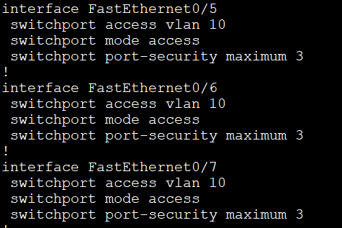

This shows the access ports on S1 and their configuration. They are assigned to VLAN 10 and have port security allowing 3 MAC addresses.

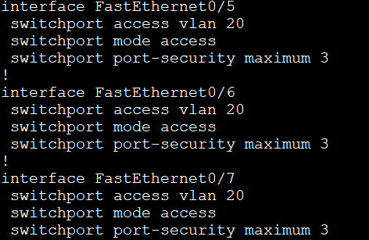

This shows the access ports on S2 and their configuration. They are assigned to VLAN 20 and have port security allowing 3 MAC addresses.

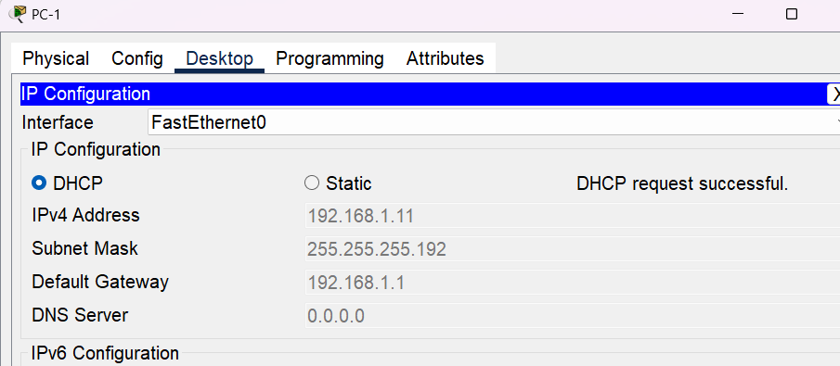

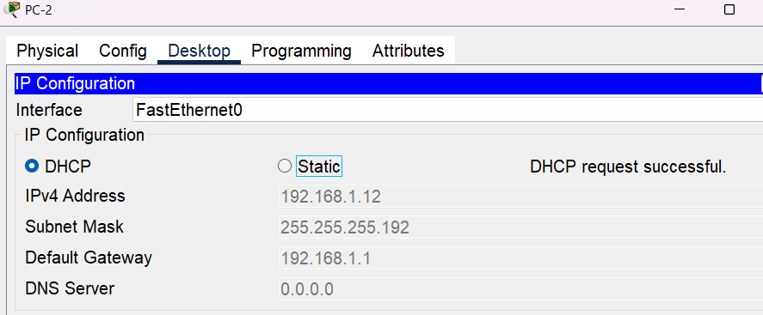

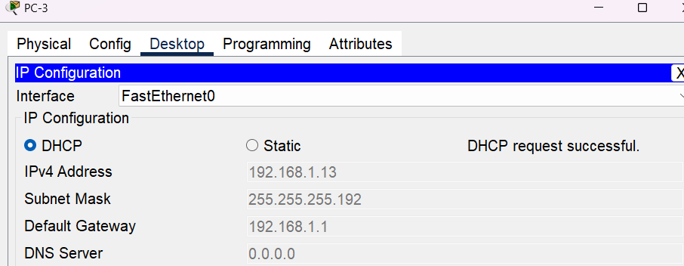

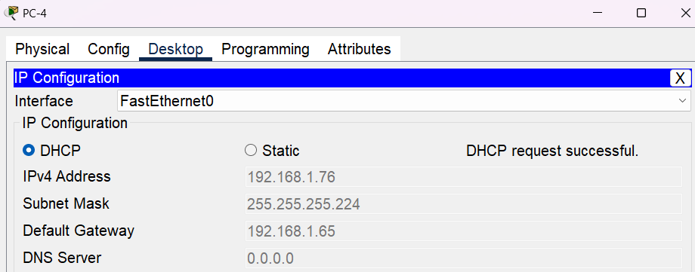

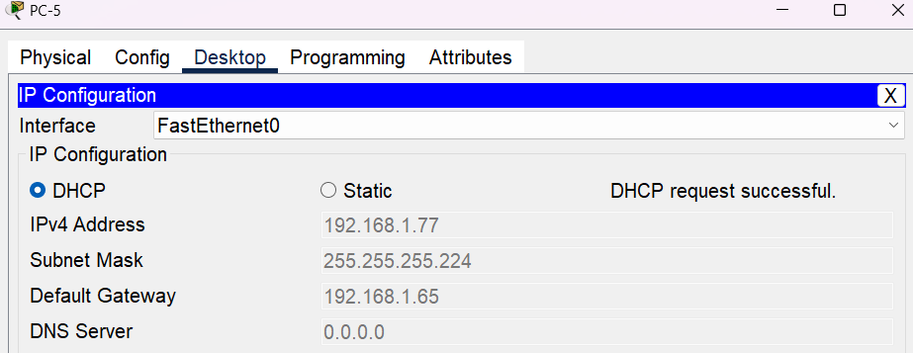

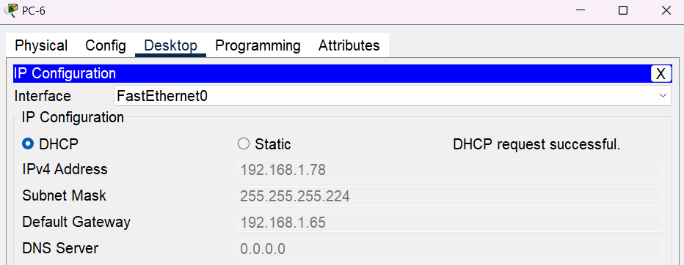

After all the configuration was done on the routers, switches and the server, each PC was able to get an IP address using DHCP successfully.